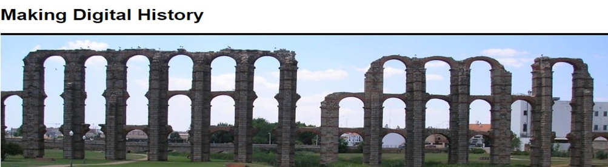

Project Title: Active Online Reading Project

Project Description
This project will explore how we can enhance students’ reading practices. The digitisation of resources, the emergence of virtual learning environments, and the widespread use of mobile devices have all profoundly altered how students engage with learning resources. Yet we know strikingly little about how students read online, how this relates to their overall learning, and which pedagogic strategies are effective. This project will investigate current practice around digital reading and will produce a suite of resources to support students across all subjects.

Student Bursaries
To help evaluate this funded project, the School of History & Heritage is awarding several student bursaries. This is an opportunity for students to apply research skills to an active project and work alongside principal investigator (PI) Dr Jamie Wood and co-investigators (CI) Dr Anna Rich-Abad (Nottingham) and Dr Jon Chandler (UCL).
The student researchers will primarily be involved with gathering data on the reading practices of their peers via questionnaire surveys/ focus groups/analysis of online reading practices. It is anticipated that through the use of social media and online platforms, student researchers would be able to capture and record data users' experiences, behaviours, attitudes and opinions in relation to Talis Elevate and other online reading tools and practices.
Six student bursaries of £500 are available to support the Active Online Reading research project over the period of up to twelve weeks, and we are anticipating a time commitment of an average of two hours a week, plus mentorship.

Student Researcher
The student researcher will assist with data gathering and analysis of the reading practices of their peers via surveys/ focus groups/ analysis of online reading practices. The role will also involve:
- Working with the project co-ordinator(s)
- Helping to design protocols for capturing feedback
- Disseminating the results of their research – each student researcher will be expected to write at least one blog post
- Working closely with external stakeholders including other team members/students at other institutions.

Applications are open to students of any discipline at any stage of their studies (UG or PG) with interest in education and experience with extra-curricular learning, research methods and design, and experience and/or knowledge of social media and online platforms.

Support
Students who receive the bursaries will work closely with a member of the Active Online Reading team who will act as their mentor and provide support and informal training.

Timeline
Timeline | Activity
September 2021 | Assist with the design of the research
October 2021 | Data gathering across and within institutions
November 2021 | Data analysis
December 2021 | Write at least one blog post
September-December2021 | Contribute to the publishing case studies and other resources

Eligibility
- The funding will be awarded to undergraduate or postgraduate students of the University of Lincoln (3 bursaries), UCL (1 bursary), Sheffield Hallam University (1 bursary), the University of Salford (1 bursary), and the University of Nottingham (2 bursaries).
- Students should discuss the opportunity with their personal tutor and have an endorsement from a member of staff (ideally your personal tutor or dissertation supervisor).

Application Process
- Applicants should complete the attached application form and send it to ngrace@lincoln.ac.uk, (Nguyen Grace) by noon on 10 September 2021. Late application will not be considered.
- All application forms will be reviewed by the Active Online Reading Project team.
- Applicants will be selected based on their suitability to deliver the above outlined project.
- Interviews will be schedule on the discretion of the evaluation panel.
- The successful applicants will be managed in accordance with the institution’s safeguarding, health & safety and risk management processes and procedures.
- Application outcomes will be communicated to all applicants by 17th September 2021.

Additional Information
- The work for this project must be completed by the end of December 2021. This project is expected to start in mid-September 2021.
- Bursaries will be paid in two instalments, subject to satisfactory progress, determined by Dr Jamie Wood (PI), Dr Anna Rich-Abad (CI) and Dr Jon Chandler (CI)
- Successful applicants will need access to a laptop or PC, MS Teams and software to help them to analyse data.
Application Form
Project Title: Active Online Reading Project

Personal details
Your Name
Student Number
Contact Number
Email
Institution
Degree Programme
Programme Level/Year

Personal Statement
Motivation statement (max 200 words): Outline why you are interested in working on the above project.

Suitability statement (max 200 words): Outline how your experience (degrees, projects, modules) qualifies you for the project.

Qualifications: Provide information on your academic qualification (e.g. completed degrees, relevant module grades, or others).

Declarations
To be completed by applicant:
I understand and agree to the above project outlines. | Yes/No
I am confident that I have sufficient time capacity to complete this project within the timescale stated. | Yes/No
Date
Signature

To be completed by personal tutor (UG students).
I am unconcerned about the additional time commitment for the applicant, should they be selected. | Yes/No
Date
Signature

To be completed by dissertation supervisor (third-year UG students only):
I am unconcerned about the additional time commitment for the applicant, should they be selected. | Yes/No
Date
Signature
Please send this form to ngrace@lincoln.ac.uk (Nguyen Grace, Project Assistant) by noon on 10 September 2021.

